**Project Synopsis**

**On**



**Movie Flix**

***Table of Contents***

|  |  |  |
| --- | --- | --- |
| **S. No.** | **Topic Name** | **Page No.** |
| 1 | Title of the project | 1 |
| 2 | Introduction and Objectives of the Project | 3-5 |
| 3 | Module Description | 6-8 |
| 4 | Analysis (DFDs, ER Diagram) | 9-12 |
| 5 | Data Structure | 13-17 |
| 6 | Software & Hardware Tools | 18-19 |
| 7 | Future Scope | 20 |

**Introduction of Project**

|  |
| --- |
|  |

In this case, we will be designing a simple online movie rental. The site will provide a soothing experience for customers. The system will allow more than one category of movies of different banners. Customer can send pick-up request to us for the movie that he wants to borrow for few numbers of days. Our one of the staff member delivered that movie within a day at the customer place and picked up the movie. Rental charges of each movie are same for all our customer but number of movies a user can borrow at a time is depends on its membership plan.

**Project Objective**

|  |
| --- |
|  |

**Objective**

This project has been developed keeping in view the security features that need to be implemented in the networks following the fulfillment of these objectives:

* Provide a user friendly interface to the user such that he can borrow movie for few days & he can also create his queue.
* User can make a request of the required movie from his queue for delivery.

**Assumptions**

The currency followed is Rs as the site provides for only Indian customer base.

* There are different segments, categories, brands where a brand can fall under more than one category.
* The shipment of the goods is not covered under the scope of the case
* Complains by the customers are not handled by the case study.
* Customers have to be validated before the payment can be confirmed.

**Project Overview**

A customer visits the online movie rental. A customer may select any movie that he wants to borrow or just visit the page and logout. The customer can select a genre, then a language, to get the different movies as he desired. And there are various other ways that a user can search for his desired movie.

The customer can select the movie for putting them in his queue. The process can be repeated for more movies. Once the customer finishes selecting the movie/s the queue can be viewed, if the customer wants to edit the final queue it can be done here. Customer can update or delete movies for his queue anytime.

For final delivery of selected borrowed movie, the customer has to login the portal, if the customer is visiting for the 1st time he must register with the site, else the customer must use the login page to proceed.

Finally customer has to request for the desired movie from the queue for delivery. That movie is delivered at their place within a day also picked up from there after few days or requested by the customer to pick this movie or pick and deliver next movie.

**Module Description**

|  |
| --- |
|  |

**Modules:**

1. Registration
2. Search
3. Report
4. Security
5. Admin
6. Staff
7. User

**Brief Description:**

**Registration:**

Through this module a person can register with the website. A registered user can add movies to the queue and see rental history and update his profile. A user can keep any int of movies as he wishes, but only the first movie is delivered to him in the next delivery cycle. A person needs to choose a plan to be registered and join with us. Valid email id is required as user id.

**Search:** This module is the most important module of this project. Visitor & User can search movie by various ways. These ways are explained as below

1. By Combination of Language & Genre
2. By Alphabet
3. By Collection
   1. By year like movies of 80's, 90's or 2000
   2. By Award Winning movies

(NOTE: These above two options are available for both Indian and International Category)

1. By Name of
   1. Actor
   2. Actress
   3. Producer
   4. Director

**Report:**

This module works for us whenever admin or user wants to take a report of any type like…

1. Admin can take a report of all payment made by any user during registration
2. Admin can also take report of all customer details
3. Rental history that shows disc to be delivered as well as or disc to be picked up.

**Security:** Security is one of the most important aspects of any project. Following security measures have been taken:

**Login:**

**This is a sub module of Security Module.** This module authenticates and authorizes the user. If the user has forgotten the password then Once visitor is registered with us, now can borrow movie from us but before that he has to choose or make a queue that he/she want to watch in future. And also reserve his/her movie for delivery at his/her place. Session is created after successful login

**Logout:**

This module is again sub module of Security. Session expires after successful logout

**Captcha**

A captcha is a set of letters and or numbers presented under the form of a small picture. The trick is that the captcha containing letters and or numbers is distorted badly. Basically, the captcha is designed to be able to make a distinction between human started submission of web-forms and automated software queries, and help separate them accordingly.

**Auto Logout**

If no requests come from the same user for the next 30 minutes then user is logged out automatically.

**Admin:** Admin is the only authorized person who governs this site. He can perform following activities:

1. Add Movie/ Membership Plan / Staff
2. Update Profile/Password/Movie Details/Movie Image/Int Of Discs
3. Delete Movie
4. Reports
   1. Payment Details
   2. Delivery Details
   3. Discs Details
   4. Posted Feedbacks

**User:** User can search any movie from his/her choice and make a queue according with that. Now, he/she can reserve any movie or delete any movie from the queue. If he/she reserve any movie its mean that he/she want that movie to be delivered to him.

1. My Profile
2. Add Movie To Queue/ Deliver or Reserve List
3. Update Profile / Password
4. View
   1. My Queue
   2. Rental History
   3. Popular Movies
   4. Locate Stores
   5. New Membership Plans
5. Post Feedback

**Staff**: our Staff person is that, who delivered and take back movie to the respective user on time.

1. My Profile
2. Update Profile / Password
3. Check New Movie Delivery Requests
4. Reports New Delivery Requests

**Analysis**

|  |
| --- |
|  |

## Data Flow Diagram

*Data Flow Diagram*

The Data flow Diagram shows the flow of data. It is generally made of symbols given below: -

1. A rectangle shows the Source/Sink: -
2. A Circle shows the Process: -
3. An open Ended Rectangle shows the data store : -
4. An arrow shows the data flow :-

The DFD can be up to several levels. The 0 level DFD states the flow of data in the system as seen from the outward in each module.

The first level DFD show more detail, about the single process of the 0 level DFD

The second level DFD can show even more details and so on.

**Context Level Diagram**

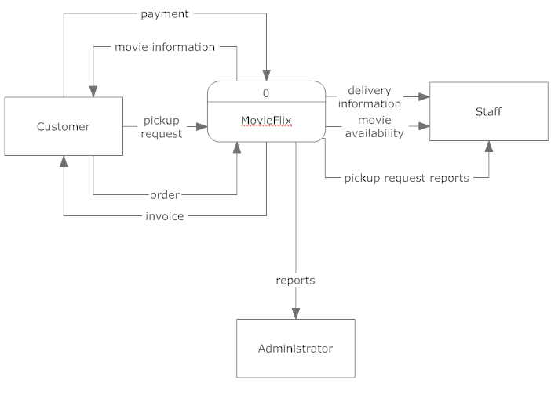**Level – 0 Diagram**

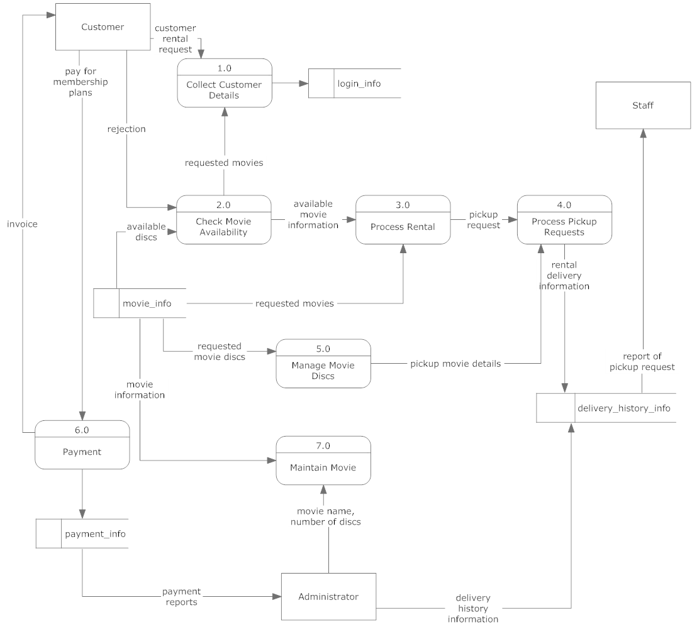**ER Diagram**

Data Structure

Address

Lname

Fname

Role

User_id

plan_id

user_info

sex

Mobile

DOB

login_info

user_id

sec_answer

sec_ques

password

movie_info

movie_id

Movie_name

Released_date

Censor_certified

Language

Producer

Director

Actor

Actress

Image_name

Nation

genre_info

genre_id

genre_name

movie_genre_info

movie_genre_id

movie_id

genre_id

award_info

award_id

movie_id

award_name

award_year

queue_info

movie_id

cart_id

user_id

queue_id

cart_info

user_id

totalcost

Purchased_date

Purchased_time

payment_id

payment_info

cart_id

payment_type

amount

cart_id

cartitem_info

cartitem_id

quantity

totalcost

movie_id

comment_id

comment_info

Comment_type

comment_by

Person_email

Comment_on

Remarks

buys

M

M

added to

made of

1

N

done for

1

1

does

1

N

can post

can add

1

N

have

1

1

M

M

can have

have

1

1

have

1

1

have

1

1

1

N

1

N

plan_info

plan_id

Plan_name

no_of_discs_at_a_

time

refundable_amt

Subscription_amt

plan_duration

plan_type

has

N

1

award_winning

_status

|  |
| --- |
|  |

1. Table: plan_info

To maintain the records of different plans

|  |  |  |  |  |
| --- | --- | --- | --- | --- |
| Column Name | Data Type | Size | Constraint | Description |
| plan_id | Int | 5 | Primary key | Plan id of the plan |
| Plan_name | Varchar | 30 | Not null | Name of the plan |
| plan_type | Varchar | 10 | Not null | Type of plan |
| plan_duration | Varchar | 12 |  | Duration of the plan |
| Subscription_amt | Int | 5 | Not null | Amount to subscribe the plan |
| refundable_amt | Int | 5 | Not null | Refundable amount |
| no_of_discs_at_a_time | Int | 10 | Not null | No of discs provided to the user |

1. Table: user_info

To maintain the records of different user either he/she is admin or user

|  |  |  |  |  |
| --- | --- | --- | --- | --- |
| Column Name | Data Type | Size | Constraint | Description |
| User_id | Varchar | 20 | Primary Key | User ID of user |
| plan_id | Int | 5 | Foreign key |  |
| Role | Varchar | 10 | Not null | Role of user |
| Fname | Varchar | 20 | Not null | First name of user |
| Lname | Varchar | 20 |  | Last name of user |
| Sex | Varchar | 6 | Male, Female | Gender of the user |
| Address | Varchar | 50 |  | Address of user |
| Mobile | Int | 10 | Not null | Mobile int of user |
| DOB | date |  | Not null | Date of birth of user |

1. Table: login_info

To maintain the username and the related password of different admin/user/staff

|  |  |  |  |  |
| --- | --- | --- | --- | --- |
| Column Name | Data Type | Size | Constraint | Description |
| User_id | Varchar | 20 | Foreign key | Valid email |
| Password | Varchar | 20 | Not null | Password of user for login |
| Sec_ques | Varchar | 20 | Not null | Security question of user for regaining the password details |
| Sec_answer | Varchar | 50 | Not null | Security answer of user for regaining the password details |

1. Table: movie_info

To maintain the username and the related password of different admin/user

|  |  |  |  |  |
| --- | --- | --- | --- | --- |
| Column Name | Data Type | Size | Constraint | Description |
| Movie_id | Int | 5 | Primary key | Movie id of the movie |
| Movie_name | Varchar | 20 | Not null | Name of the movie |
| Released_date | Date |  |  | Released date of the movie |
| Director | Varchar | 20 | Not null | Director of the movie |
| Actor | Varchar | 20 | Not null | Male Actor of the movie |
| Actress | Varchar | 20 | Not null | Female Actor of the movie |
| Producer | Varchar | 20 | Not null | Producer of the movie |
| Language | Varchar | 10 | Not null | Language of the movie |
| Censor_certified | Varchar | 5 | A, U/A, U | Censor certificate of the movie |
| Image_name | Varchar | 30 | Not null | Name of the image |
| award_winning_status | Int | 1 | 1 or 0 | This shows that movie is award winning or not. By default movie is not award winning |
| Nation | Varchar | 13 | Indian or International | Nationality of the movie |
| No_of_discs | Int | 5 | Not null | No of discs of a particular movie |

1. Table: genre_info

To maintain the records of different genre

|  |  |  |  |  |
| --- | --- | --- | --- | --- |
| Column Name | Data Type | Size | Constraint | Description |
| genre_id | Int | 5 | Primary Key | Genre ID |
| genre_name | Varchar | 15 | Action, Comedy, Drama, Horror, Family, Spiritual, Historical, Romance, etc | Name of the genre |

1. Table: movie_genre_info

To maintain the records of each movie with its genre

|  |  |  |  |  |
| --- | --- | --- | --- | --- |
| Column Name | Data Type | Size | Constraint | Description |
| movie_ genre _id | int | 5 | Primary key | Combine ID of both Movie ID & Genre ID |
| movie_id | Int | 5 | Foreign key | Movie ID |
| genre _id | Int | 5 | Foreign Key | Genre ID |

1. Table: award _info

To maintain the records of awards of each movie

|  |  |  |  |  |
| --- | --- | --- | --- | --- |
| Column Name | Data Type | Size | Constraint | Description |
| award_id | Int | 5 | Primary Key | Category ID |
| Movie_id | Int | 5 | Foreign key | Movie ID |
| award_name | Varchar | 30 |  | Name of the award |
| award_year | Date |  |  | On what date award is given to the movie |

1. Table: queue _info

To maintain the records of movies added by the user in queue

|  |  |  |  |  |
| --- | --- | --- | --- | --- |
| Column Name | Data Type | Size | Constraint | Description |
| queue_id | Int | 10 | Primary key | Queue ID |
| movie_id | Int | 10 | Foreign key | Movie ID |
| user_id | Varchar | 20 | Foreign key | User ID to whom movie is allotted |
| status | Varchar | 20 |  | Status of the movie that is either awaiting, delivered or reserve |
| Reserved_date | date |  | Not null | On what date movie is reserved by the user |

1. Table: delivery_history _info

To maintain the records of movies that was delivered to the user

|  |  |  |  |  |
| --- | --- | --- | --- | --- |
| Column_name | Data Type | Size | Constraint | Description |
| delivery_history _id | Int | 5 | Primary Key | Delivery ID |
| Movie_id | Int | 5 | Foreign key | Movie ID of the movie_info table |
| User_id | Varchar | 20 | Foreign key | User ID of the user_info table |
| delivered_on | Date |  | Not null | Delivery date of the movie |
| Returned _on | Date |  | Not null | Returned date of the movie |
| Delivered_by | Varchar | 5 | Foreign key | User ID of a specific staff from the user_info table who delivered this movie to the user |

1. Table: request _info

To maintain the records of movies that are requested by the user from his/her queue

|  |  |  |  |  |
| --- | --- | --- | --- | --- |
| Column Name | Data Type | Size | Constraint | Description |
| request_id | Int | 5 | Primary Key | Request ID |
| Queue_id | Int | 5 | Foreign Key | Queue ID of the queue_info table |

1. Table: payment _info

To maintain the records of payment of each payment when user chooses his/her membership plan

|  |  |  |  |  |
| --- | --- | --- | --- | --- |
| Column Name | Data Type | Size | Constraint | Description |
| Payment_id | Int | 5 | Primary Key | Payment ID |
| User_id | Varchar | 20 | Foreign key | User ID of the user_info table to check who pay this payment to us |
| Payment_type | Varchar | 10 | Credit Card | Type of payment user want to pay |
| Amount | int | 5 | Not null | Amount of payment that was paid by user |
| Payment_date | Date | 7 | Not null | Payment date |
| Payment_time | Varchar | 5 | Not null | Payment time |

1. Table: comment _info

To maintain the records of comments posted by the user

|  |  |  |  |  |
| --- | --- | --- | --- | --- |
| Column Name | Data Type | Size | Constraint | Description |
| Comment_id | Int | 5 | Primary Key |  |
| Comment_type | Varchar | 10 | Suggestion, Complaint, Query | Types of comments the user can post |
| Comment_on | Varchar | 10 | Mall Services, Stores, Dining, Staff, Others | Thing on which user want to comment |
| comment_by | Varchar | 10 |  | Name of the person who post the comment |
| Person_email | Varchar | 30 | Not null | Email address of the person |
| Remarks | Varchar | 100 | Not null | The comment that he/she want to post |

**Software & Hardware Tools**

|  |
| --- |
|  |

**Development Environment:**

* **Operating System:** Linux Red Hat, Windows XP SP2 or above

The system will be built on windows compatible environment. The application will be web based developed using Java technology.

* **Integrated Development Environment(IDE):** Eclipse Helios

Eclipse is a multi-language software development environment comprising an integrated development environment (IDE) and an extensible plug-in system.

* **Web Server:** Tomcat 7.0

Apache Tomcat is an open source software implementation of the Java Servlet and Java Server Pages technologies. Apache Tomcat is an open source software implementation of the Java Servlet and Java Server Pages technologies.

* **Data Base**: My SQL 5.0

MySQL is a relational database management system (RDBMS) that runs as a server providing multi-user access to a int of databases.

* **Client Browsers:**

Support all browsers

* **Dream Weaver CS5**

The system will be developed with Java Technologies using J2SE (JDK and JRE). Dream Weaver CS5 as HTML editor

**Hardware & Software Requirements:**

**Hardware requirement**

Main Processor Pentium IV or above

Hard-disk Capacity 8 G.B or more

RAM 256 MB or more

**Software Requirement**

Operating System Linux Red Hat, Window XP SP2 or other

Backend tool My SQL 5.0

**Future Scope**

|  |
| --- |
|  |

1. Providing the SMS alerts of latest movies to the user.
2. Providing Email account facility to users so they can feel the independence of mail account at the same site.
3. Provide email facility to the user of all the upcoming movies & their details for rental.